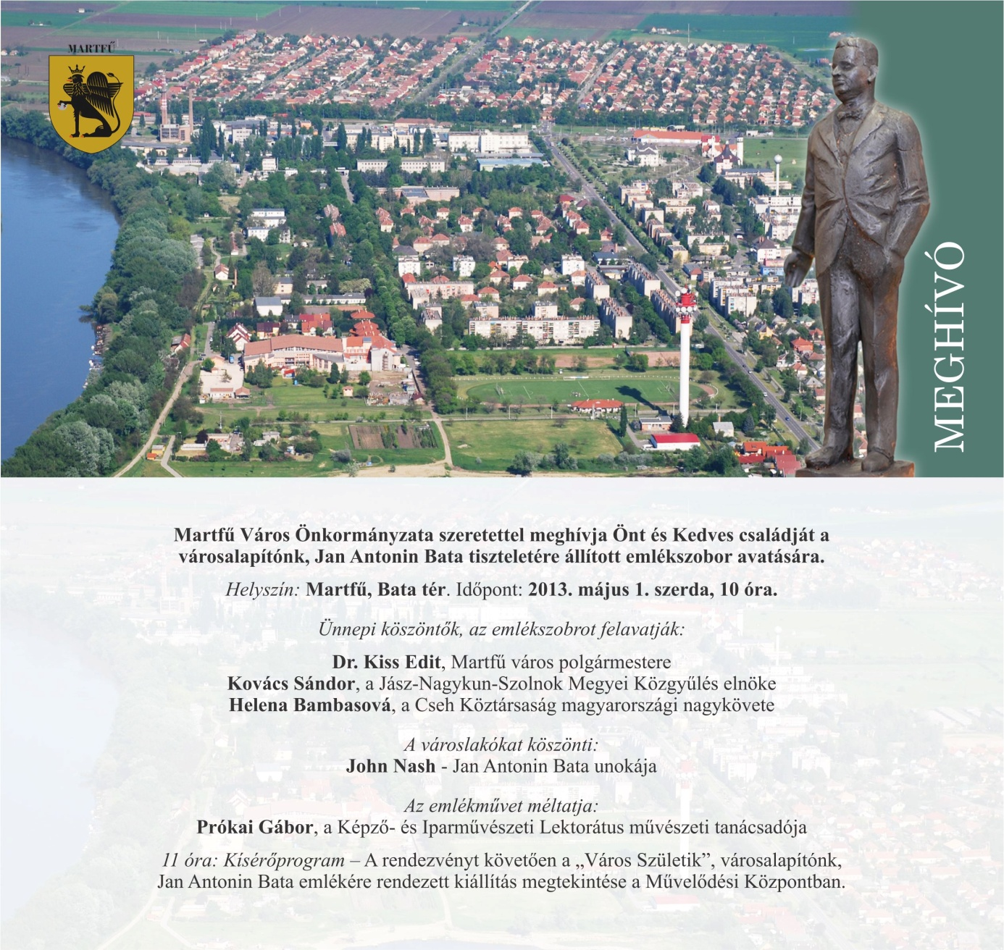

Invitation
You and your family are cordially invited to the statue unveiling in celebration of Jan Antonin Bata, founder of Martfű.
Location: Bata Square
Date: 1st May 2013, Wednesday, 10 am
Opening speeches:
Edit Kiss, Mayor of Martfű
Sándor Kovács, Chairman of Jász-Nagykun-Szolnok County’s Council
Helena Bambasová, Ambassador of the Czech Republic
John Nash, Jan Antonin Bata’s grandchild
Gábor Prókai, Lector of Museum of Applied Arts

11 am ’ Birth of a new city’, Exhibition of Jan Antonin Bata in the Culture House of Martfű

