Benes
Freemason Lodge
Atheists
“Stefanik’s death in the version is due to a Freemasons’ plot and a conspiracy of Czech atheists against Slovak Catholics or a collusion of Socialists or even Bolsheviks.”
“The reason in both cases was similar: to thwart the rule of Catholic powers in Danubian Europe.”
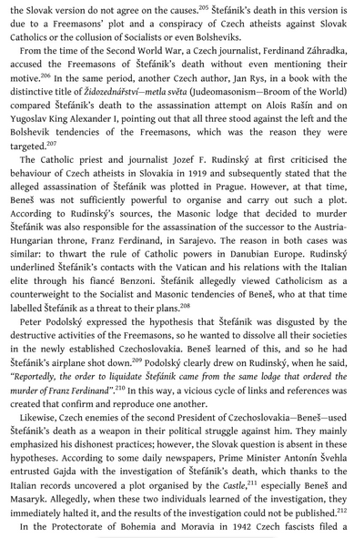
“Stefanik allegedly viewed Catholicism as a counterweight to the Socialist and Masonic tendencies of Benes, who at the time labelled Stefanik as a threat to their plans”
“Peter Podolsky expressed the hypothesis that Stefanik was disgusted by the destructive activities of the Freemasons, so he wanted to dissolve all their societies in the newly established Czechoslovakia. Benes learned of this so he had Stefanik’s airplane shot down. Podosky clearly drew on Rudinsky, when he said, ‘Reportedly, the order to order to liquidate Stefanik came from the same lodge that ordered the murder of Franz Ferdinand’”

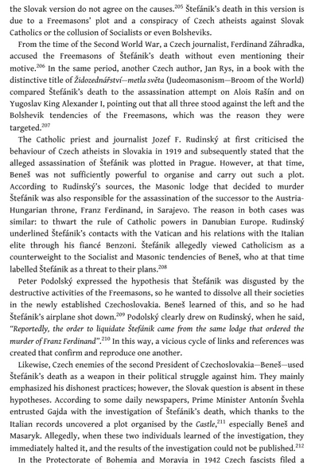
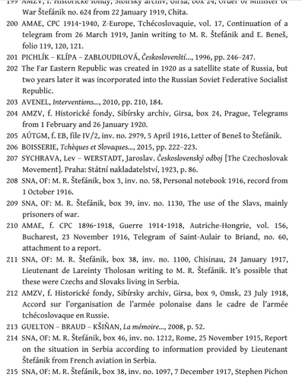
Milan Rastislav Štefánik The Slovak National Hero and Co-Founder of Czechoslovakia Michal Kšiňan 2021

